**Assignment 6 – Services App**

**Name : Snehal Yeole**

**SJSU ID : 012548471**

**Services Application Home Screen:**

The home screen for Services application shown below consist of five EditTexts for PDF files links to download using the Android Services in background and a start download button which starts downloading the given PDF files on Click event. I am using the links given in the assignment description for demo.

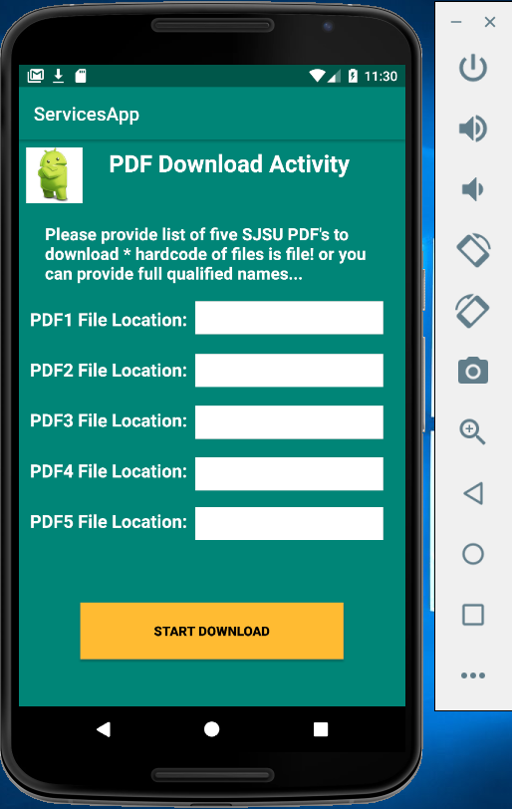

**Home Screen with the PDF links**

The Home Screen with PDF links to download set in the EditText box is shown below

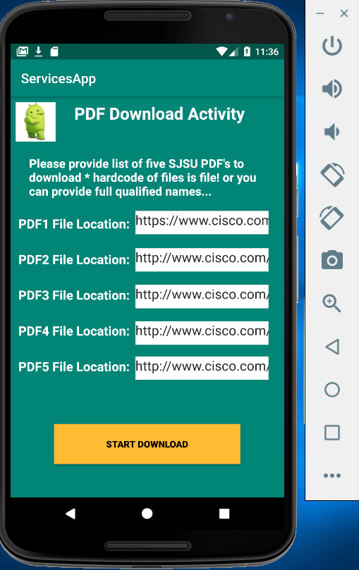

**onClick Start Download button:**

On clicking the Start Download button, the PDF files are downloaded to the directory set by the user. I am downloading the files in **Downloads** directory.

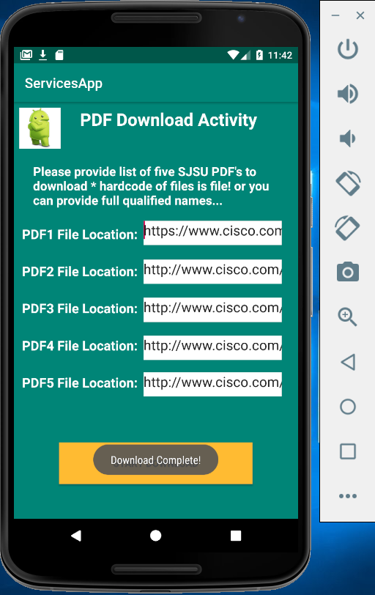

The **Download Complete!** Message is shown for each PDF file download action.

**Home Screen for each PDF link:**

Link 1 : <https://www.cisco.com/c/en/us/about.html>

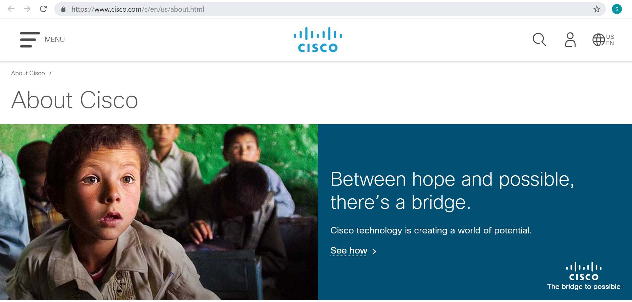

Link 2 : <https://www.cisco.com/c/dam/en_us/about/ac79/docs/innov/IoE_Economy.pdf>

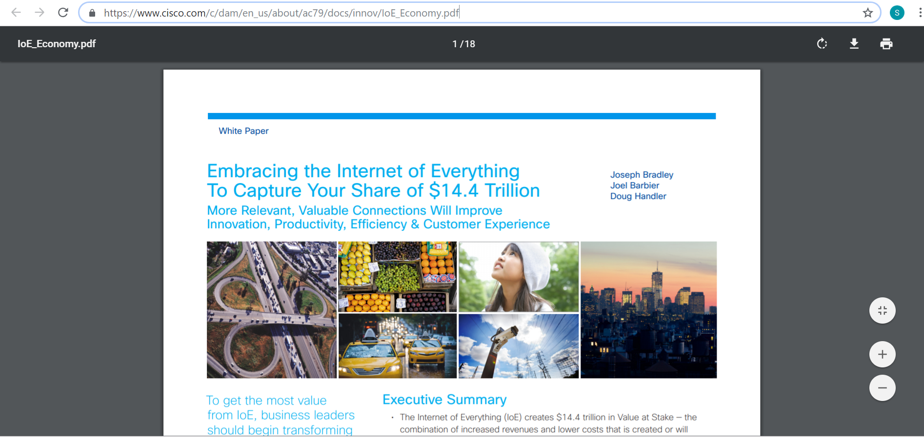

Link 3 : <https://www.cisco.com/c/dam/en_us/solutions/industries/docs/gov/everything-for-cities.pdf>

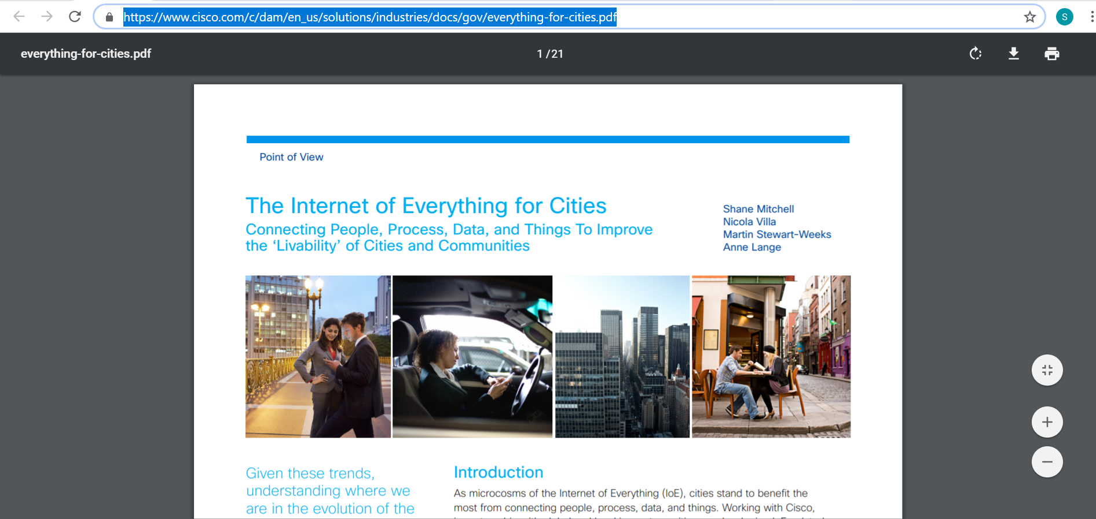

Link 4 : <https://www.cisco.com/web/offer/gist_ty2_asset/Cisco_2014_ASR.pdf>

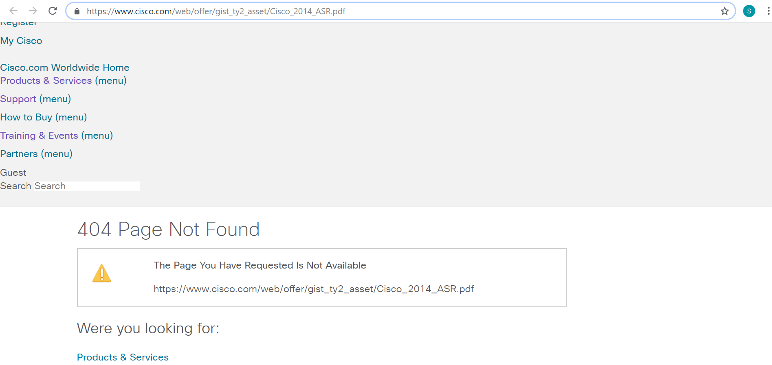

Link 5 : <https://www.cisco.com/web/offer/emear/38586/images/Presentations/P3.pdf>

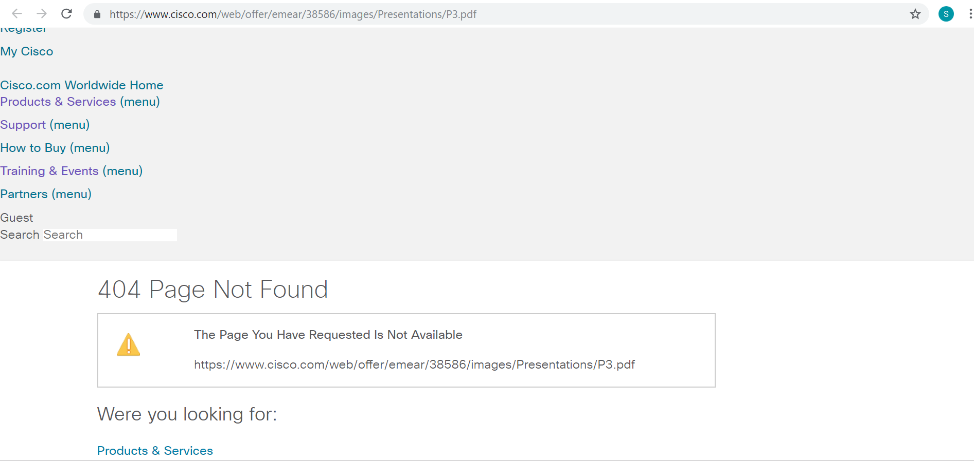

As we can see in the Device Explorer, only the first three PDF files are downloaded. The other two files returns 404 on opening so it cannot be downloaded.

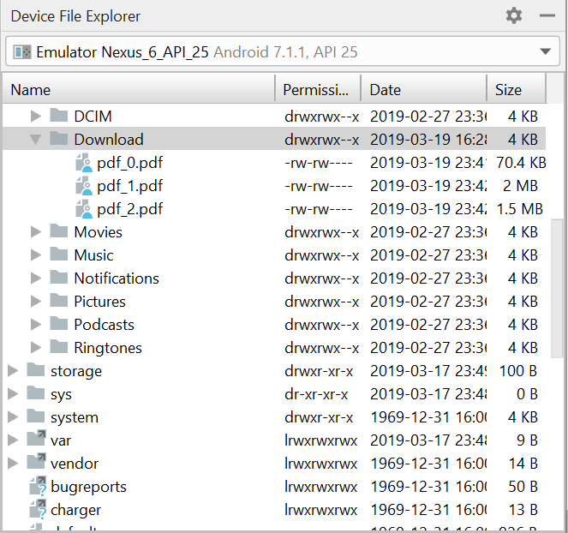

Now let’s check the downloaded files in the simulator’s Downloads directory

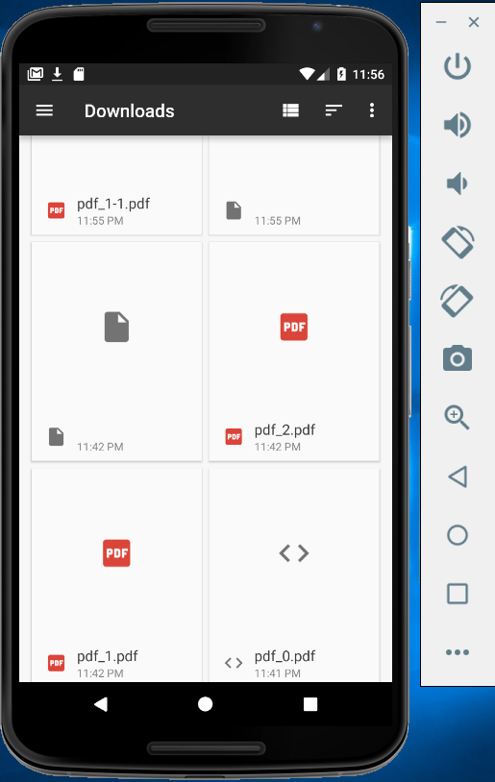

Pdf_0, pdf_1 and pdf_2 are downloaded. The last two files download is failed.

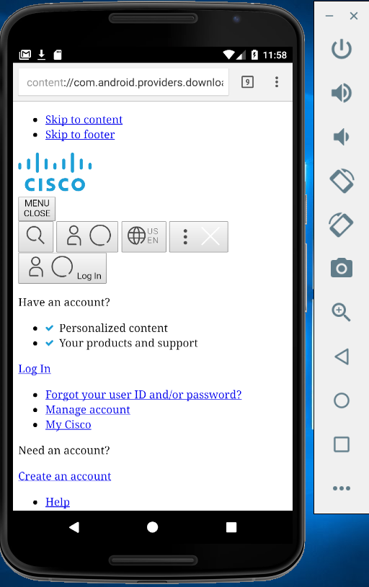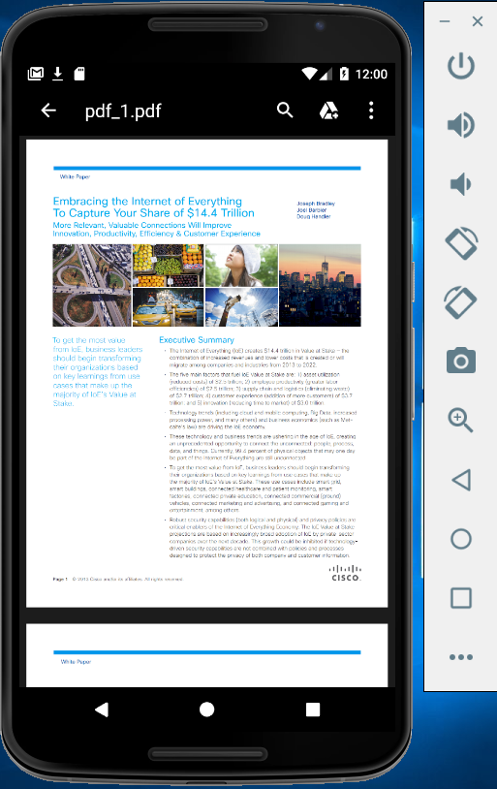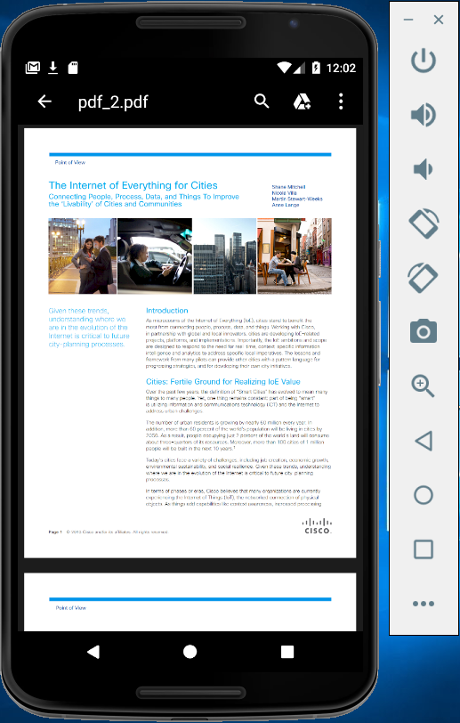

Pdf_0.pdf pdf_1.pdf pdf_2.pdf

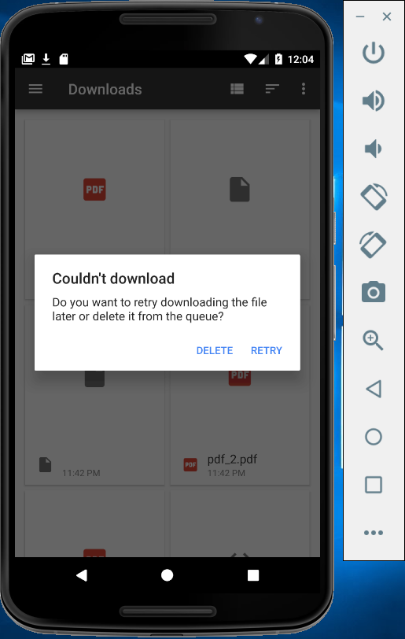

The other two files pdf_3.pdf and pdf_4.pdf are not downloaded because of 404 status

Now, let’s try downloading San Jose State University PDF files from the internet

Link 1 : <http://www.sjsu.edu/specialed/programs/current-semester-courses/Fall_18_EDSE%20218C_Janel_Astor.pdf>

Link 2 : <http://www.sjsu.edu/provost/academic_affairs/resources/Academic_Calendars/Summer%202018.pdf>

Link 3 : <http://www.sjsu.edu/provost/docs/AY%20Calendar%2017-18.pdf>

Link 4 : <http://www.sjsu.edu/provost/academic_affairs/resources/Academic_Calendars/Summer%202014_Combined.pdf>

Link 5 : <http://www.sjsu.edu/provost/docs/2010_Summer_Calendar.pdf>

**Home Screen with San Jose State University PDF files links:**

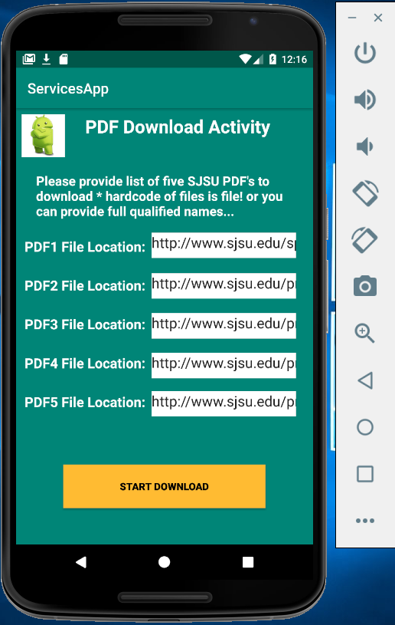

**On Click Start Download button:**

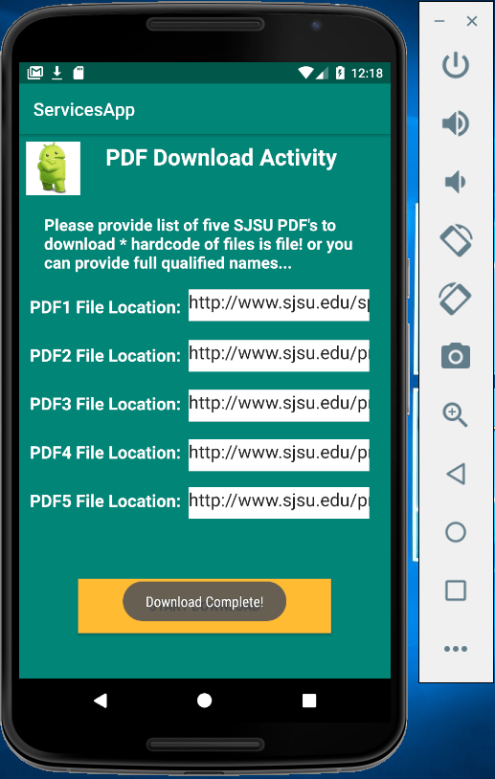

The Download Complete! message is displayed for each downloaded PDF files.

Let’s go and check the downloaded PDF files in the Downloads directory in a Device Explorer in Android Studio

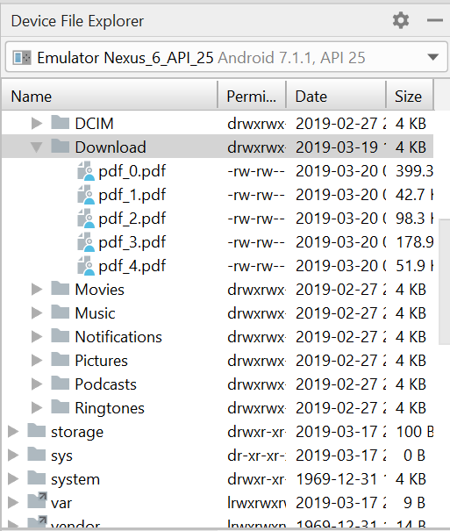

Now check in the Downloads directory of a simulator

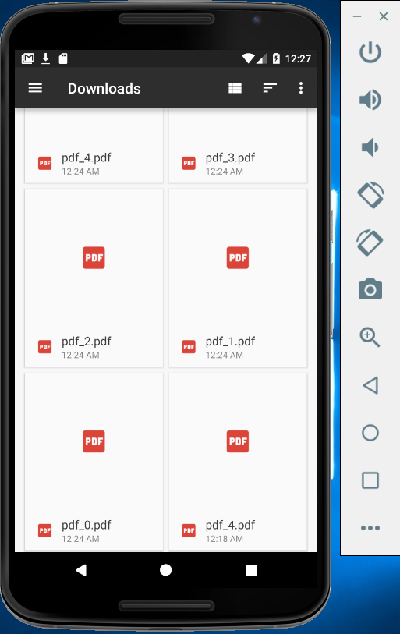

All the PDF files are downloaded

**The screenshots of downloaded PDF files:**

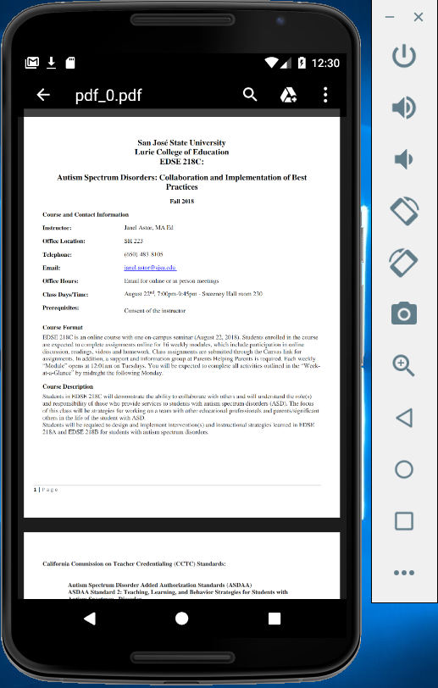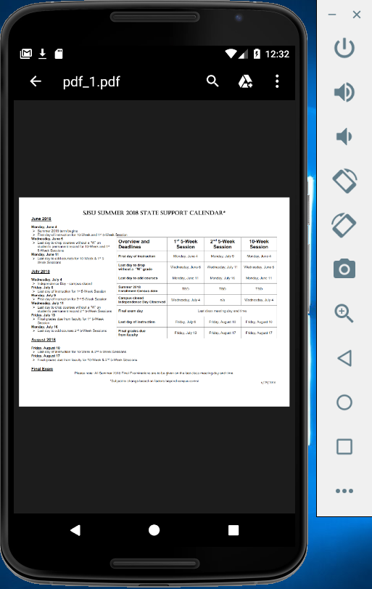

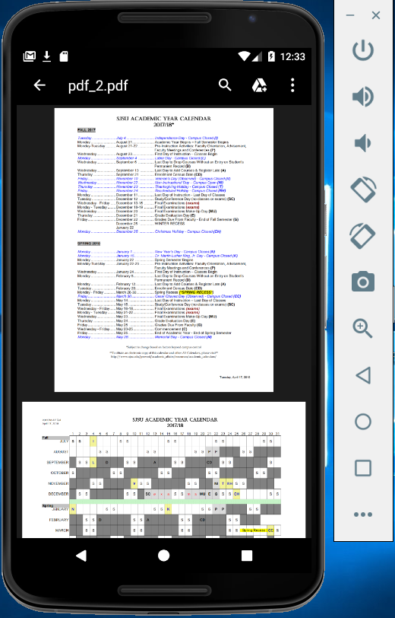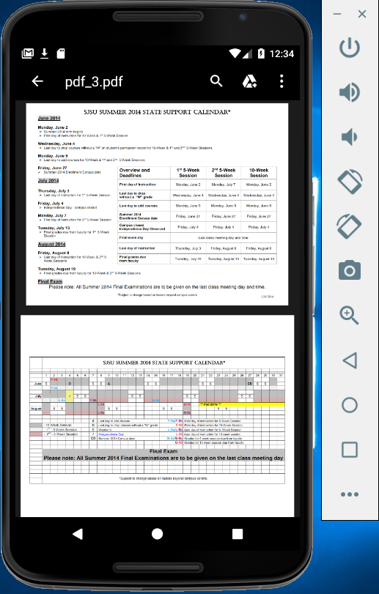

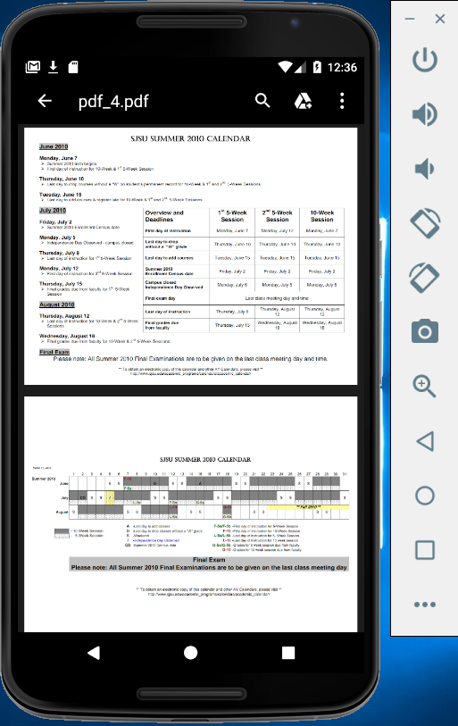

**Demo Link with Cisco PDF files:**

<https://drive.google.com/file/d/1j8qVWnip3aMO7fAuDvTbjYLkdoBA68xI/view?usp=sharing>

**Demo Link with San Jose State University PDF files:**

<https://drive.google.com/file/d/1dt8l6ziIeQqPb2Enck07WhMQ6jzb7fs4/view?usp=sharing>

**References:**

<https://developer.android.com/guide/components/services>

<https://www.tutorialspoint.com/android/android_services.htm>